
University of Frontier Technology, Bangladesh
Department of Internet of Things and Robotics Engineering

Course Code | CC 484
Course Title | Cloud Computing Sessional

LAB REPORT
On
Lab Final Task

Submitted To
Farzana Akter
Assistant Professor
Department of Internet of Things and Robotics Engineering
University of Frontier Technology, Bangladesh
Submitted By
Sl | Class Roll | Name | Session
01 | 2201022 | Mst. Esat Jahan Akhi | 2022-2023
02 | 2201021 | Sukria Akter | 2022-2023

Date of Submission
September 18, 2026

1. Objectives
- The primary objective of this lab session is to gain practical experience with core Microsoft Azure services, including:
- Deploying and configuring a Linux Virtual Machine (IaaS).
- Managing unstructured data storage using Azure Blob Storage Account (PaaS).

Deploying a web application using Azure App Service (PaaS).
2. Task 1: Create and Configure a Linux Virtual Machine

2.1 Overview & Implementation Steps
- Navigated to the Azure Portal and created a new Linux Virtual Machine under the Resource Group Lab1_RG.
- Configured the VM name as LinuxVM1 in the Korea Central region running Linux (ubuntu 24.04) OS.
- Selected the Standard D2s v3 size (2 vCPUs, 8 GB memory).

Configured network interfaces and successfully deployed the resource.
2.2 Deployment Verification & Network Properties
Deployment Status: Deployment complete successfully.
Resource Group: Lab1_RG
VM Name: LinuxVM1
Operating System: Linux (ubuntu 24.04)
VM Size: Standard D2s v3 (2 vCPUs, 8 GB memory)
Status: Running
Public IP Address: 40.82.128.203
Private IP Address: 172.16.0.4

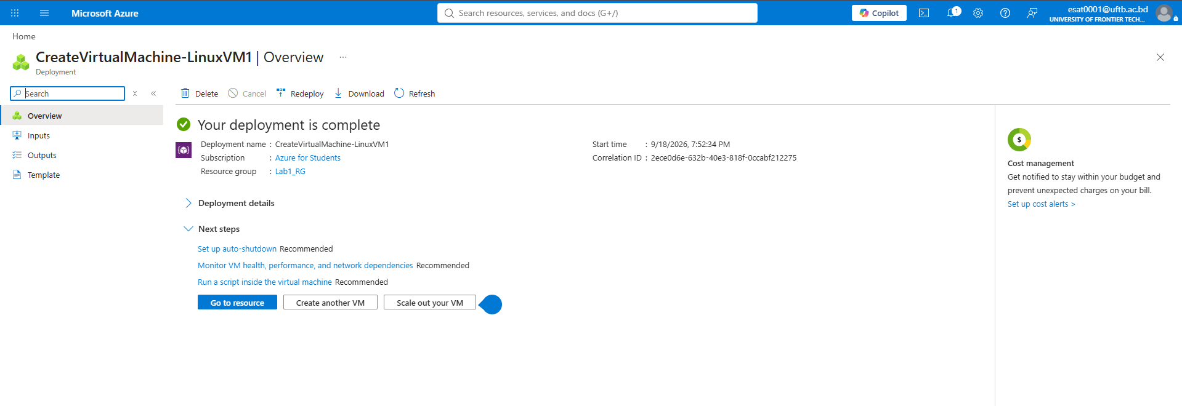
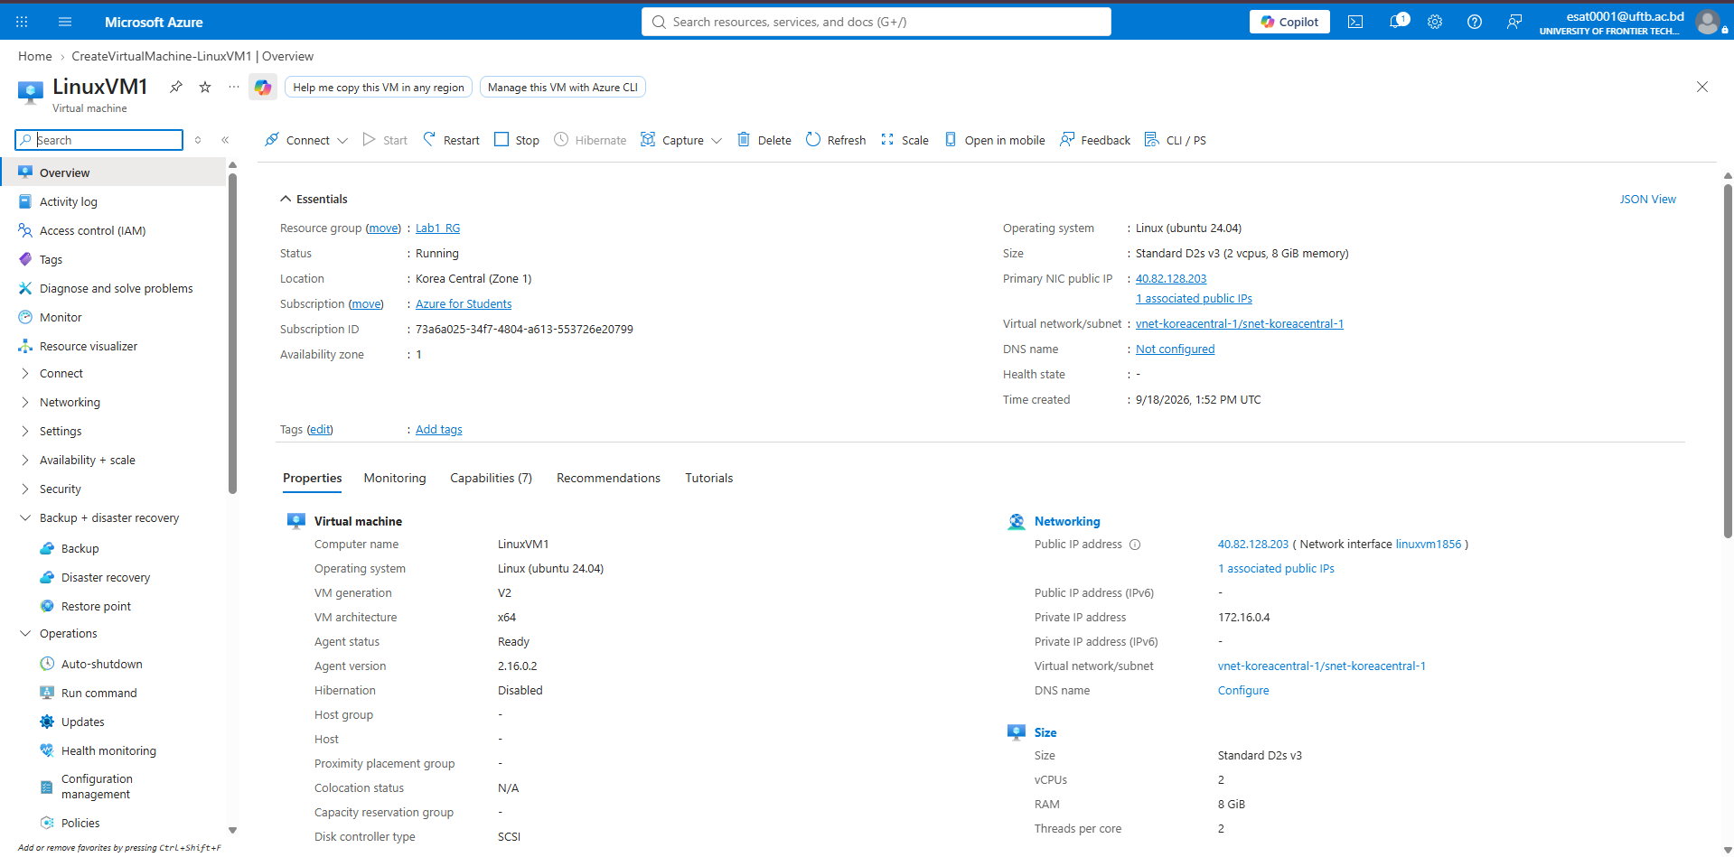
fig.Task 1: Create a Linux Virtual Machine
Task 2: Create Azure Storage Account and Blob Container

3.1 Overview & Implementation Steps
Created an Azure Storage Account named esatstorage2201022 under Lab1_RG in Korea Central.
Provisioned a Blob Container named sample-container.
Uploaded a file named sample.txt containing string data.
Verified direct access to the stored file via its generated URL ([https://esatstorage2201022.blob.core.windows.net/sample-container/sample.txt](https://esatstorage2201022.blob.core.windows.net/sample-container/sample.txt)).

3.2 Key Technical Details
Storage Account Name: esatstorage2201022
Account Kind: StorageV2 (general purpose v2)
Replication: Locally-redundant storage (LRS)
Container Name: sample-container
Uploaded File: sample.txt (Size: 42 B, Content-Type: text/plain)
File Content: "Hello, Azure Storage!" This is Esat :)!!

3.3 Theoretical Concepts
Storage Account Purpose: Serves as a unique, secure, and centralized namespace in Azure to manage scalable storage services (Blobs, Files, Queues, Tables).

Blob Container Purpose: Functions like a directory to organize unstructured binary large objects (files, images, media, text) accessible securely over HTTP/HTTPS.
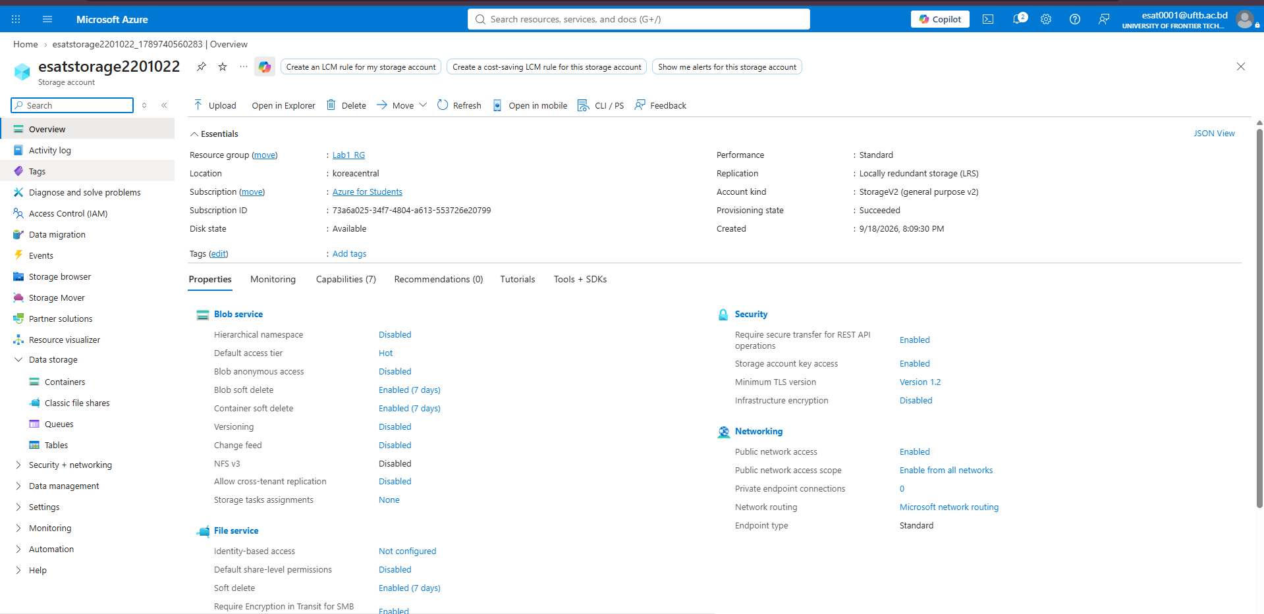
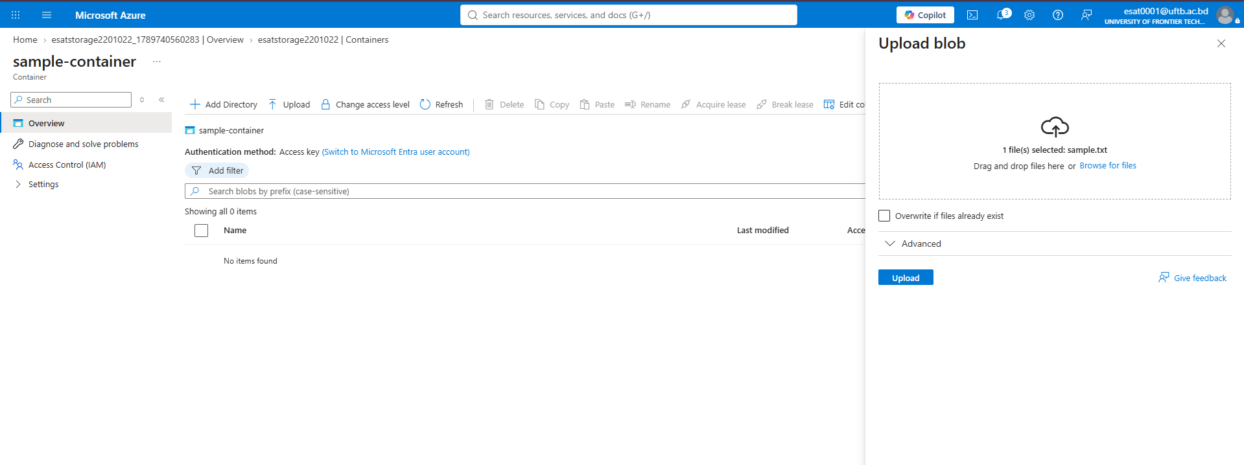
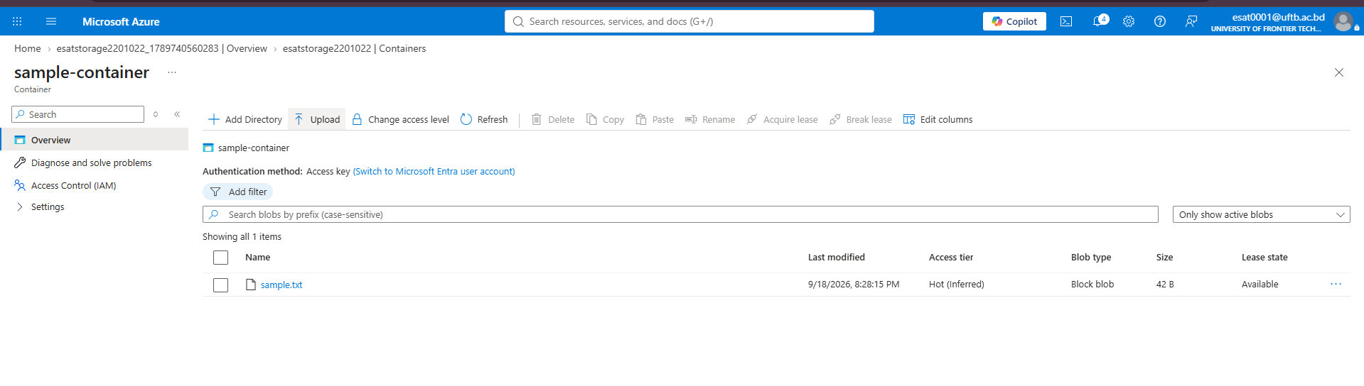
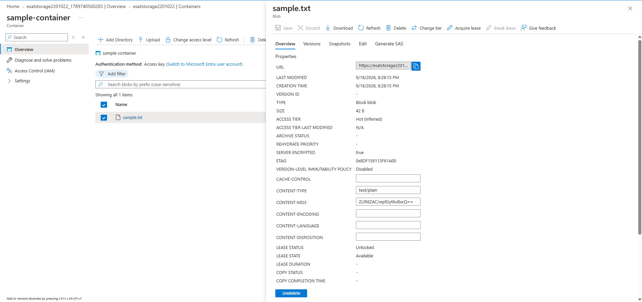
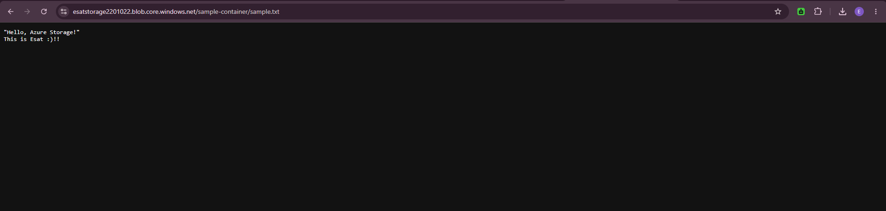
fig. Task 2: Create an Azure Storage Account and Blob Container
4. Task 3: Create Azure App Service Web App and Deploy Application

4.1 Overview & Implementation Steps
Created an Azure App Service instance named studentweb-2201022 targeting Php - 8.2 runtime stack on Linux OS.
Accessed the container management interface via Advanced Tools (Kudu) and connected using SSH Application Container.
Executed shell commands (cat << 'EOF' > ...) to deploy custom web application code directly to /home/site/wwwroot/index.php.
Formatted the application with a responsive CSS dashboard interface displaying student information.

4.2 Application Details & Verification
App Name: studentweb-2201022
App Service Plan: ASP-Lab1RG-b069 (Basic SKU)
Generated URL: [https://studentweb-2201022-cnh7dvhkf8c8atft.koreacentral-01.azurewebsites.net](https://studentweb-2201022-cnh7dvhkf8c8atft.koreacentral-01.azurewebsites.net)
Deployed Webpage Output: Displays "Welcome to Cloud Computing Lab", Student Names ("Mst. Esat Jahan Akhi & Sukria Akter"), and Student IDs ("2201022 & 2201021") inside a styled dark-themed UI container.

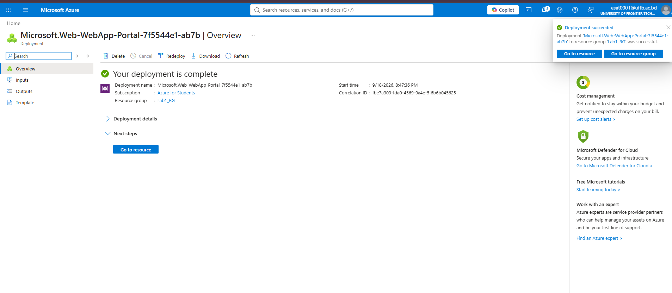
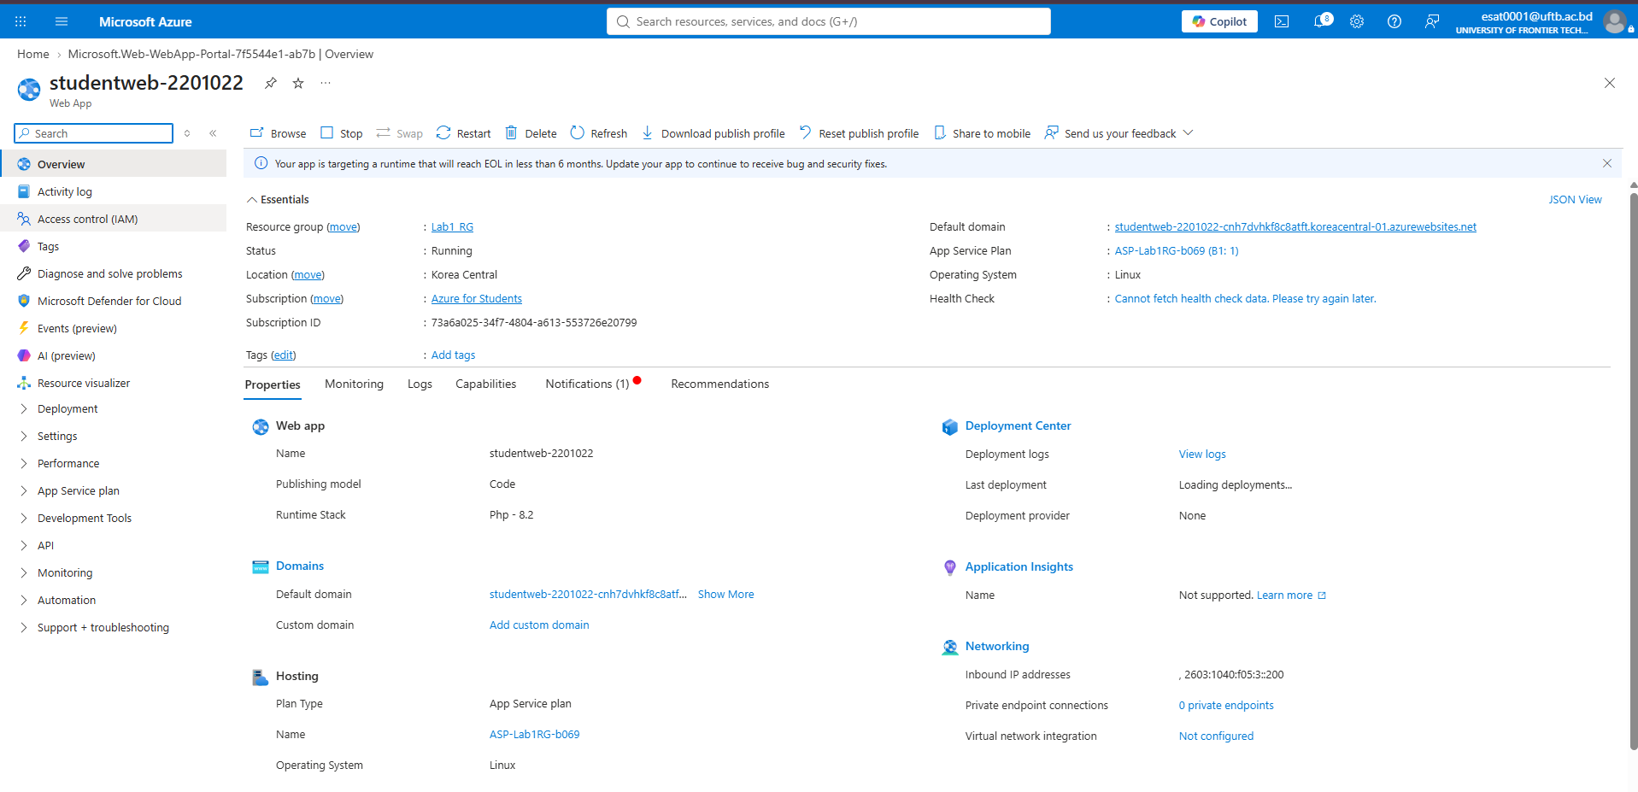
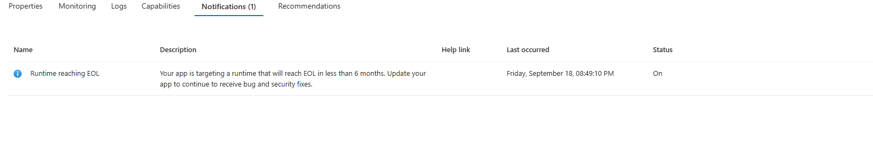
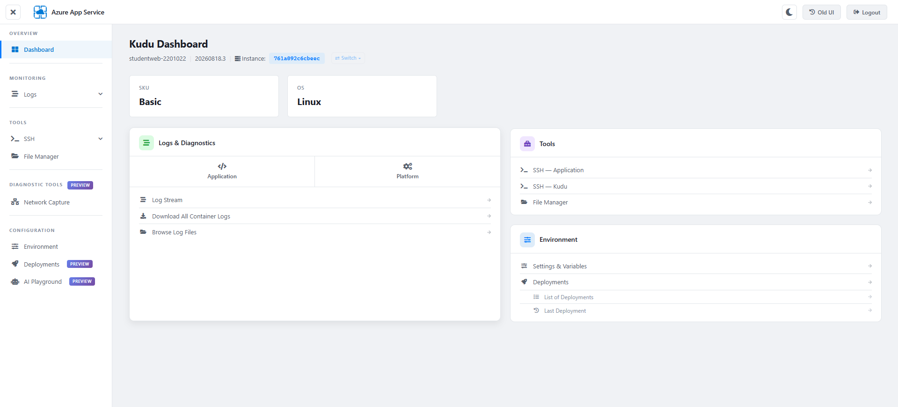
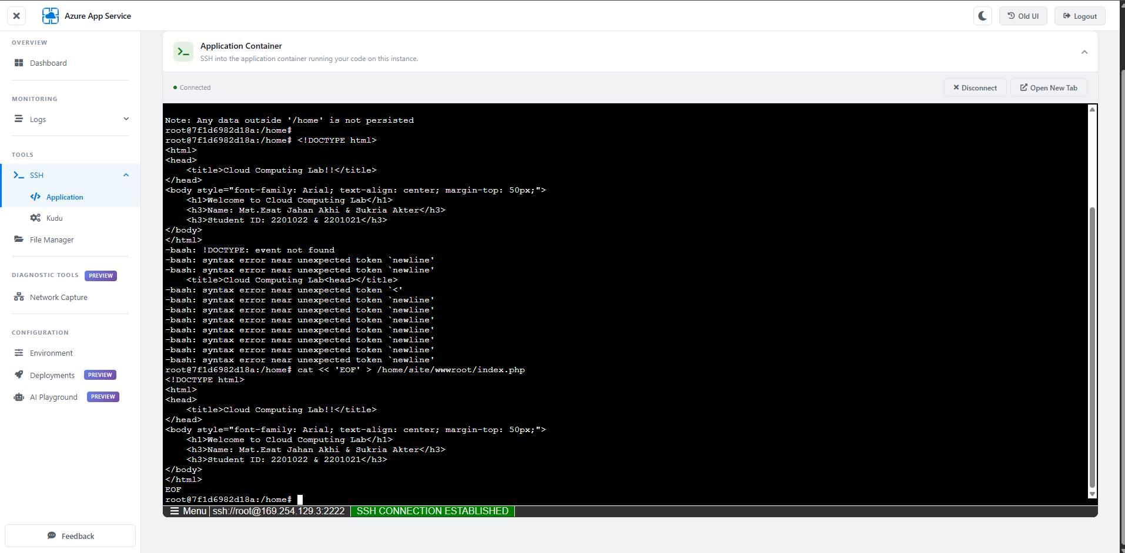
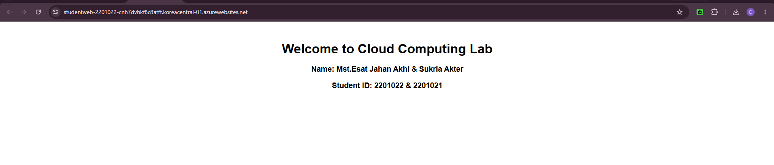
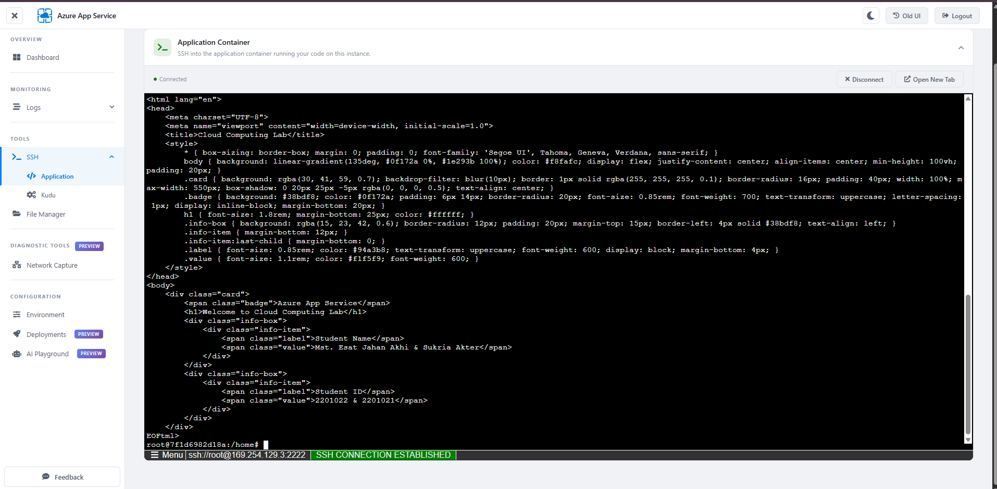
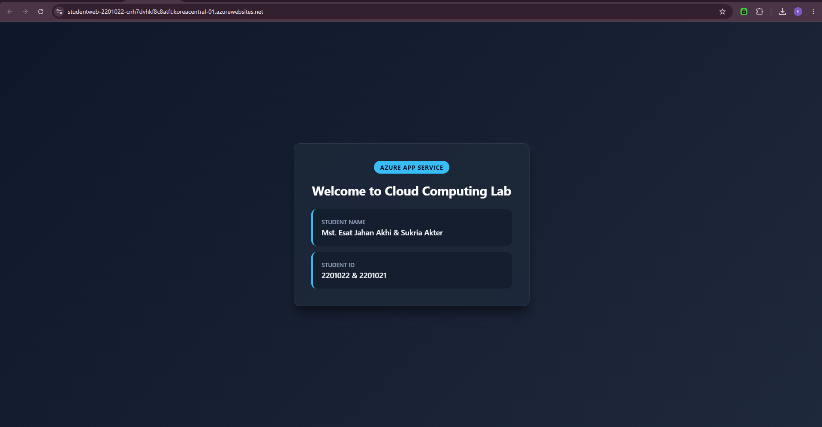
fig.Task 3: Create an Azure App Service Web App
5. Conclusion
All three tasks outlined in the lab guidelines were successfully executed. Virtual Machine infrastructure was instantiated, persistent object storage was configured with public file retrieval, and a live web application was deployed and served publicly via Azure App Service.

